**Analysis of the factors affecting different types of debts**

**Sarvagya Dasgupta, Priyanshu Madan, Vibhor Khetan**

University of Illinois, Urbana-Champaign

Final Project (Spring-2019)

Programming for Analytics & Data Processing (IS 590 PR)

**Introduction:**

Loans Debts are crippling millions of people in the United States and it has been a major concern for the government. There is a varied range of consumer debts such as credit card debts, medical debts, student loan debts, personal loans, cell phone bills, utility bills, bank overdraft charges, auto loans, payday loans, etc. With 1.5 Trillion dollars in student loans alone, students fresh out of college who are increasingly finding it difficult to pay off their loans and defaulting on the student loan can cause serious consequences. Similarly, medical debt cripples the older population with approx 72 million people under medical debt. Due to these concerns, it is necessary to find and analyze the factors which affect the rise in debt so that necessary interventions can be introduced to keep it in check.

**Hypothesis:**

We are checking the below hypothesis to conduct the analysis:

1) States with a better public transportation system could have a lower number of vehicle loans.

2) States with a higher income might have a higher number of credit card issues than other states as in those states, credit cards are issued to a larger number of people.

3) Diving more deeply into the analysis, we would analyze the complaints registered with respect to each type of loan and the common issues faced with each of those.

Results from the analysis:

**1) Yearly loan distribution for the year 2015 and 2017**

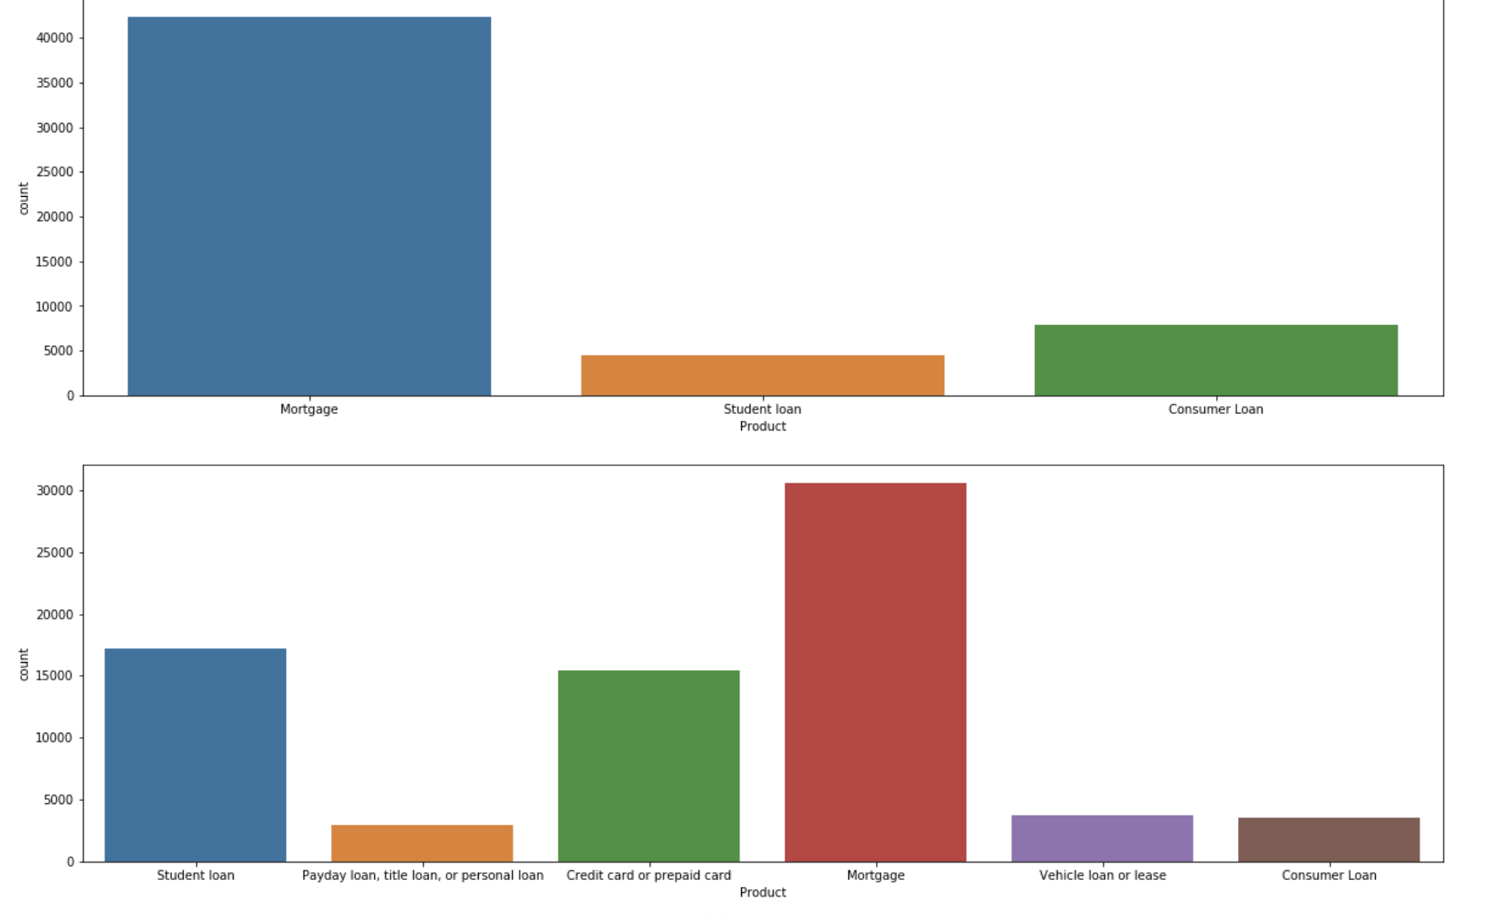

**Analysis:** In 2015, it was found that mortgage loans accounted for highest number of complaints followed by consumer loan complaints and then in 2017 Mortgage loan again had the highest number of complaints followed by student loan issue and then credit card related complaints.

**2) State wise distribution of different types of loans** 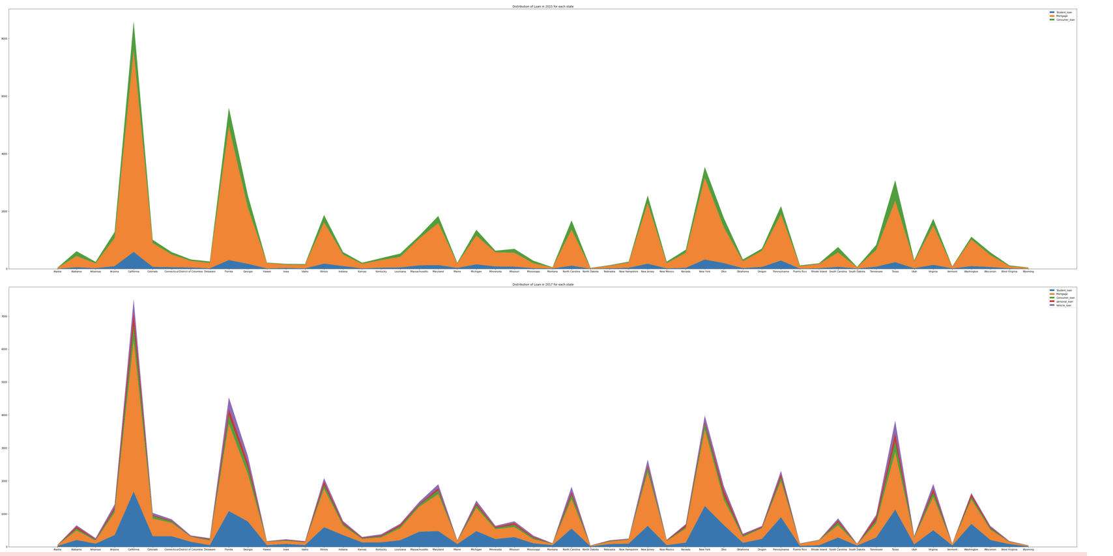

**Analysis:** From our an analysis we found that there was a significant rise in the student loan from year 2015 to 2017. We also found that California, Georgia and Florida has the highest number of registered complaints.

**3) States with a better public transportation system could have a lower number of vehicle loans.**

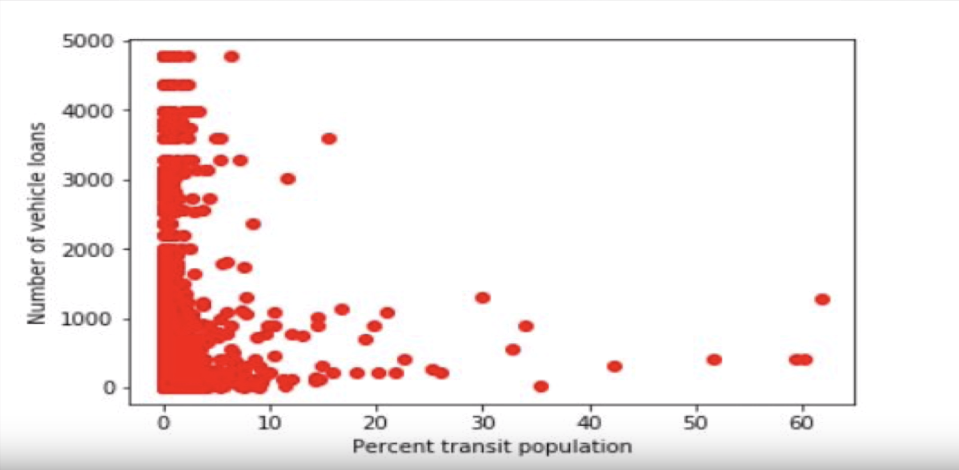

**Analysis:** According to our analysis the number of vehicle loans is independent of the public transport system. We did not find any relation between the quality of public transportation system in a state and number of vehicle loans. For most counties, approximately 10% of population prefers to commute by public transport.

**4) Analysis of companies with highest number of vehicle loans;**

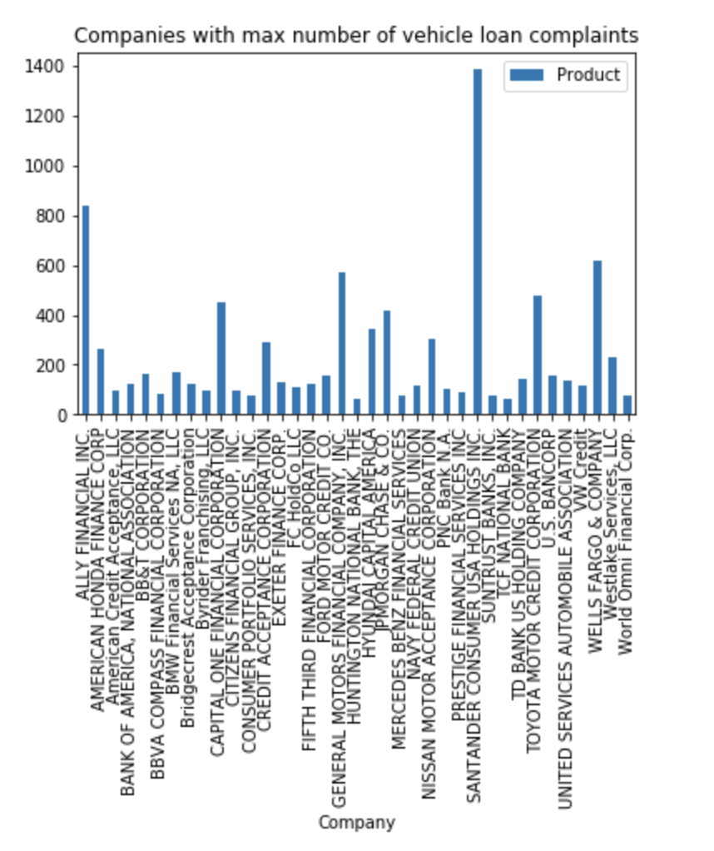

**Analysis:** According to our analysis Santander and Ally Financial received the highest number of complaints with respect to vehicle loans.

**5) Analysis of loans by region:**

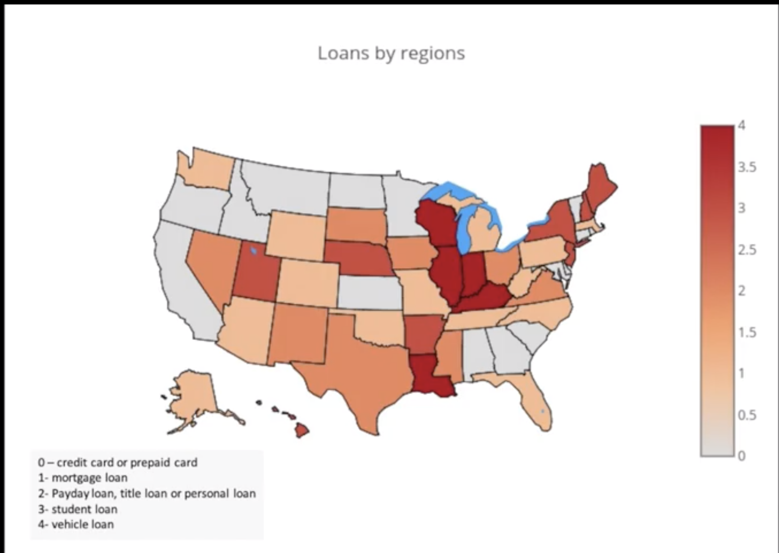

**Analysis:** Loans related to Mortgage accounted for the highest number across the US and northern states accounted for highest number of credit card loans and Midwest accounted for highest number of vehicle related loans.

**6) States with a higher income might have a higher number of credit card issues than other states**.

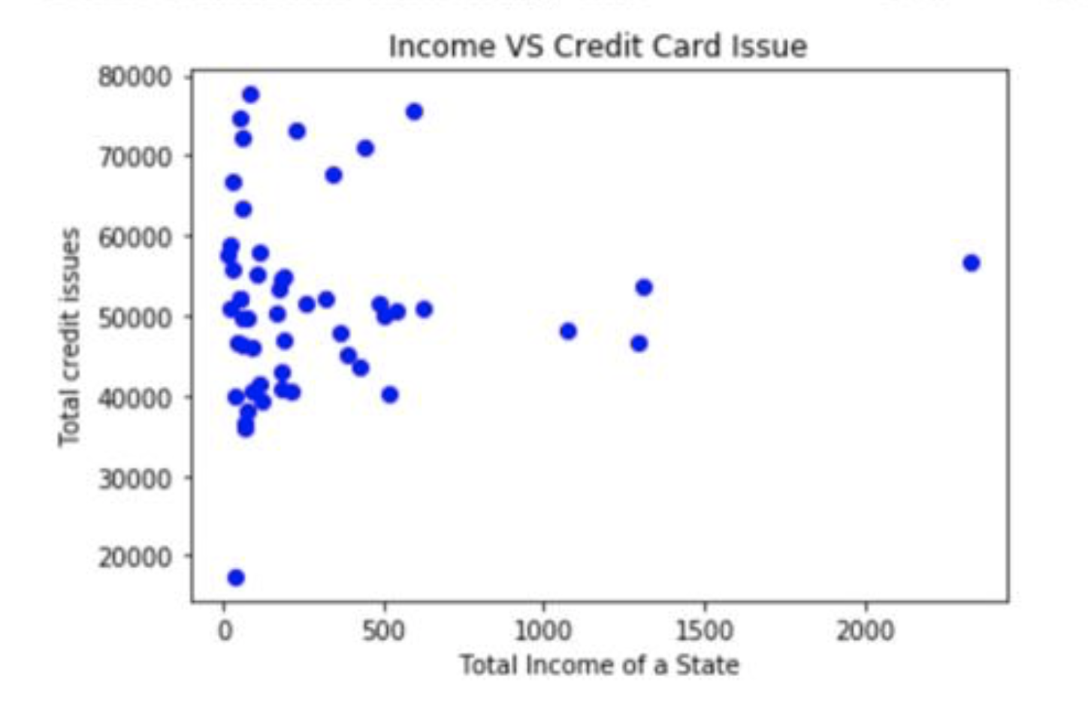

**Analysis:** In our analysis, we found that people with lower tend to have higher number of credit card issues as people with lower income face difficulty with obtaining a credit card. This is in contradiction to our hypothesis. On further analysis, we explored the breakdown of the problems associated with credit card issues. Upon viewing those, we found that the number of problems stating the inability to get a credit card exceeded other problems like theft. This is the reason why states with low income showed a large number of credit card issues as it is difficult to get a credit card if you have a low income.

**7) Table showing the data for different types of issues related to credit card:**

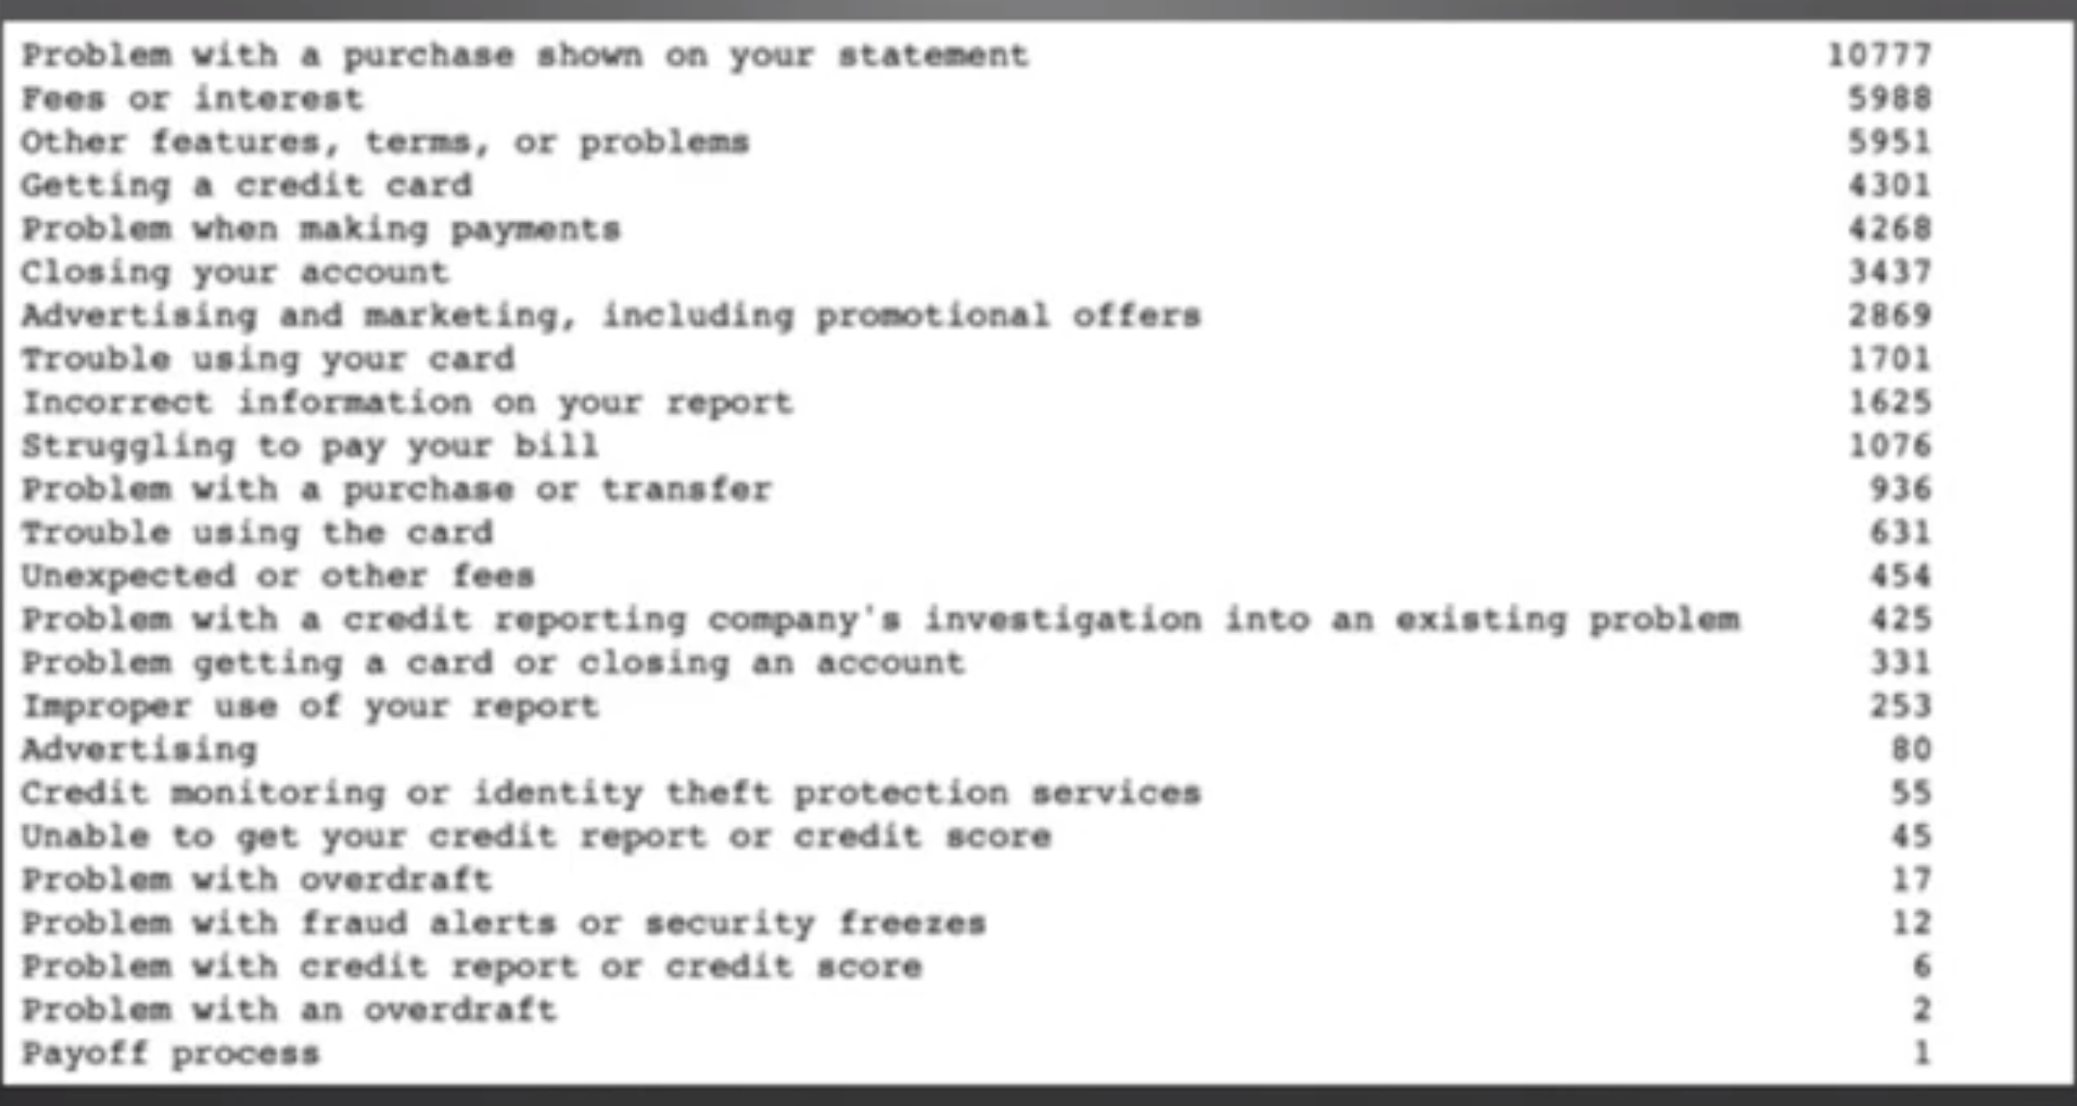

**Analysis:** In our analysis, we found that Problem with the purchase on the statement accounted for the highest number.

**8) Table below shows the response time of different companies as they resolve the issue:**

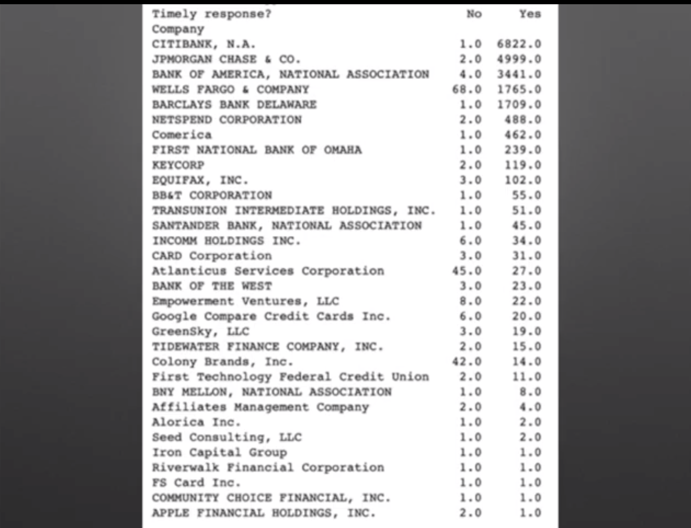

**Analysis:** We found that most companies resolved the issues in a timely manner with a few exceptions like Wells Fargo and Atlanticus Services which have the slowest response time.

**Hypothesis Test:**

1. States with a better public transportation system could have a lower number of vehicle loans. **Rejected – In our analysis we did not find any relation between number of vehicle loans and quality of public transport system.**

**2)** States with a higher income might have a higher number of credit card issues than other states as in those states, credit cards are issued to a larger number of people. **False – In our analysis we found that people with lower income tend to have more credit card related issues as they find it difficult to obtain credit card which is one of the major issue reported for credit cards.**